**REVIEW OF IIT’s Screens**

**Dates of Review: - 09th Jul’2022, 10th Jul’2022 and 11th Jul’2022**

**Opening Screen: -**

* Once the Entity is created, it should have the reference of the financial year, if not an entity created for more than time for two different years, it will be difficult to the entity specific to the FY relates.
* Once any entity is created, User has to go “Main menu” by using the key “TAB” Please check this and insert option for this without using the “MOUSE”.
* Heading for this page to be given **“Entity Creation” instead of “Entity Selection”**
* Numbering for the 1 to 7 are not required and shortcuts are ok.
* “Selection” this data field is not required, if user clicks two times with Mouse or press “Enter” on the name of the entity it should automatically be opened.
* We have not given or created, an option to open the data directly from any drive ( C or D or E or External Device). We should give Data path to copy the link and open the entity data. This is much required due to
  1. Data may not be stored in the same drive by the user
  2. Imported data has to be extracted from the external device also
  3. Some time users may copy the data web link also.
* The screen has to be divided in to exactly two equivalent parts, (other than shortcuts)
  1. For the Entity information
  2. For the Entity creation.
  3. Short cuts

**Entity creation: -**

2nd screen is to be updated with these additional features: -

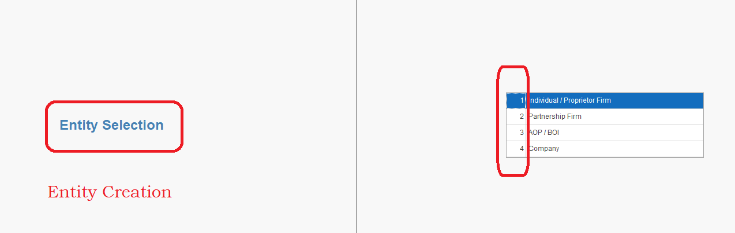

**Other persons to be added like**

* + - Co- operative society
    - Local authority
    - Trust
    - HUF
    - LLP
    - Artificial Judicial person

**(The Entity creation screens for these entities also shared to you ASAP)**



**Entity Creation: - Individual**

1. Date of Birth to be added
2. Business start date to be added
3. Capitalize Each Word (when space given in the sentence)
4. Addition of 2nd GST number is not required
5. Country code of India to be added
6. Business address to be auto updated as per GST
7. *Add logo has to be given at the right top of the screen.*
8. Save option to be deleted.

|  |  |
| --- | --- |
| **Validations** | |
| 1 | PAN No to be validation |
| 2 | GST No Validation |
| 3 | TAN No Validation |
| 4 | Address as per GST |
| 5 | Aadhar Card No's Validation |
| 6 | E mail id Validation |
| 7 | Mobile No Validation |

**“Updated format is enclosed for your reference”.**



**Entity Creation: - Firm**

1. Date of incorporation to be added
2. Capitalize Each Word (when space given in the sentence)
3. Addition of 2nd GST number is not required
4. Country code of India to be added
5. Business address to be auto updated as per GST
6. *Add logo has to be given at the right top of the screen.*
7. Save option to be deleted.
8. (Home)> Entity selection > Create\Modify Entity (If possible, enable for screen movement) based on the source of click.

|  |  |
| --- | --- |
| **Validations** | |
| 1 | PAN No to be validation |
| 2 | GST No Validation |
| 3 | TAN No Validation |
| 4 | Address as per GST |
| 5 | Aadhar Card No's Validation |
| 6 | E mail id Validation |
| 7 | Mobile No Validation |
| 8 | 100 % Capital Validation |

**“Updated format is enclosed for your reference”.**



**Entity Creation: - Company**

1. Date of incorporation to be added
2. Capitalize Each Word (when space given in the sentence)
3. Addition of 2nd GST number is not required
4. Country code of India to be added
5. Business address to be auto updated as per GST
6. *Add logo has to be given at the right top of the screen.*
7. Save option to be deleted.
8. (Home)> Entity selection > Create\Modify Entity (If possible, enable for screen movement) based on the source of click.

|  |  |
| --- | --- |
| **Validations: -** |  |
| 1 | PAN No to be validation |
| 2 | GST No Validation |
| 3 | Importing of Company CIN number based on the name |
| 4 | Address as per ROC |
| 5 | Address as per GST |
| 6 | Directors DIN No's validation |
| 7 | Aadhar Card No's Validation |
| 8 | E mail id Validation |
| 9 | Mobile No Validation |

**“Updated format is enclosed for your reference”. **

**Direct income screen**

1. If Goods are selected, reverse charge option has to automatically closed
2. GST Rates (CGST) (SGST) (IGST) water marks have to come in GST Rates.
3. Validation is only to the CGST & SGST but not IGST I.e. if user entered CGST, then SGST must be entered and vice versa
4. If user Selects only IGST, then validations should not come for CGST and SGST
5. As dotted Option is not going to second option, turn this to the drop down box model ((*Goods) (*Services)), Reverse charges (*Yes * No) and for TDS etc.
6. Opening Balances is to be deleted.
7. Save button is to be deleted.

**Debtors screen**

1. Enter button is not working after GST registration status
2. After interest clause data field, if we press “Enter” button it is going to Applicable section of TDS directly by skipping “TDS Applicability”
3. TDS section has to be fixed
4. Opening Balance has to come at the end of sheet only
5. Address details (4 Rows has to be deleted, and data from the GST has to be imported in one row with “40 to 50” row height
6. Bank details of debtors usually will not be available with recipient, so not possible to enter these details, hence entering data in this field, is specifically at the choice of user (should not be mandatory)

**Proprietors Capital screen**

1. Name is not coming automatically as per the entity registration screen.
2. Adjustments to the capital accounts as given are not required (Red Squared)



1. Save option to be deleted.
2. Capitalize each word.

**Advances to employees: -**

1. If TDS is selected as “No”, then next data field of “Applicable section of TDS is not to come, it automatically closed.
2. Applicable section is showing behind logics. Please check this 
3. Provisional entry required. This data field is not required.
4. Opening Balances is at the end of the ledger creation
5. If GST details are there, address as per GST is to be auto filled
6. Capitalize each word.
7. Save option to be deleted.
8. Even if GST option selected as “Unregistered” it is showing error mark to enter data.



**Bank Account Creation: - Current Assets**

1. Contact No of the bank is not mandatory. It should be optional.
2. Validation for the IFSC codes entered
3. If current account is selected, interest data filed is to be closed
4. Once any data entered in the red flag, red dotted mark has to disappear.

**Bank payment Voucher: -**

* Mode of transfer: - in Drop down Box
* RTGS
* NEFT
* PDC/ Cheque
* DD
* **UPI**
* **Internet/ Mobile Banking**

(These Two options have to be added).

If user selects UPI or internet/ Mobile Banking Cheque No option should not come

* Cheque no. option should come after this data field.
* Voucher No is not displayed.
* After date changed, then it is coming down automatically.
* Cheque no is starting with “0” it is to accepted with “0” also.
* Cheque No should be 6 No’s, it should not accept more than 6 digits.
* Narration of the payment is to be replaced with the word “Purpose of Payment”
* If bank balance is negative, then color has to come in **“RED”** after and before the transaction.

**Cash payment Voucher: -**

* Revised format has to inserted
* Narration of the payment is to be replaced with the word “Purpose of Payment”
* If cash balance is negative, then color has to come in **“RED”** after and before the transaction.
* Voucher No is not displayed.
* Date option is coming directly, it is not able to change much simpler.
* After date changed, then it is coming down automatically.

**Common Corrections**

**Page Layout: -**

* Boarder is not required for any ledger or voucher
* Font Size is to be increased (Amasis MT pro) with font size of 13
* Standard Row height for Data field with 25 to 30

“For every validation, green tick mark has to come. (This is to be applied to each and every validation in all ledgers)”

* Once any entity is created, User has to go “Main menu” by using the key “TAB” Please check this and insert option for this with out using the “MOUSE”.
* Paisa option is to be deleted.
* Save option is to be deleted.
* Capitalize each word.

**Common Changes in the Voucher screens: -**

* If the user is entering the vouchers, the screen, should not go back to the original screen of the vouchers. It should come back to the same screen I.e.
  + If user is in the bank payments: - it should be in the payments screen
  + If user is in the bank receipts: - it should be in the receipts screen
  + If user is in the JV: - it should be in the JV screen.
* The word “Available balance” should be restricted to only to the bank and cash ledgers only, and other ledgers should be Closing Balance only. It is applicable in all voucher entries.
* Water marks to be displayed in the debit and credit Rows.
* Voucher No. is not displaying, need to insert in all vouchers.
* Date option is coming directly, it is not able to change much simpler (Please check Tally for simple typing or edit) it is always editable while entering the voucher or after any time.